**Tribhuvan University**

**Institute Of Science and Technology**

**Birendra Multiple Campus**



**A PROJECT REPORT**

ON

**“TREKKING EQUIPMENT RENTAL”**

Submitted to

**Department of Computer Science and Information Technology**

**Birendra Multiple Campus**

***In partial fulfillment of the requirements for the Bachelor of Science in Computer Science and Information Technology***

Submitted by

**Suyog Mani Kandel** (68)(Registration no.: 5-2-19-167-2019) **(24913/076)**

**Prakriti Adhikari** (20)(Registration no.: 5-2-19-114-2019) **(24878/076)**

**Sudip Timilsina** (32)(Registration no.: 5-2-19-163-2019) **(24909/076)**

APRIL, 2024



**Tribhuvan University**

**Institute Of Science and Technology**

**Birendra Multiple Campus**

# SUPERVISOR’S RECOMMENDATION

I hereby recommend that this project prepared under my supervision by **Suyog Mani Kandel, Prakriti Adhikari, and Sudip Timilsina** entitled “**TREKKING EQUIPMENT RENTAL**” in partial fulfillment of the requirements for the Bachelor of Science in Computer Science and Information Technology is recommended for the final evaluation.

**………………………….**

**Mr. Deep Sharma**

**SUPERVISOR**

**Lecturer**

Department of Computer Science and Information Technology

Birendra Multiple Campus

Bharatpur, Nepal

Date: 2080/12/27

# APPROVAL LETTER

This is to testify to the depth of the research done into the “**Trekking Equipment Rental**” project by **Suyog Mani Kandel, Prakriti Adhikari, and Sudip Timilsina,** which was completed as a requirement for the Bachelor of Science in Computer Science and Information Technology. It is acceptable in terms of quality and scope as a project for the required degree, in our opinion.

|  |  |
| --- | --- |
| Supervisor  ………………………………….  Mr. Deep Sharma  Birendra Multiple Campus | Head / Program Coordinator  ………………………………….  Er. Binod Sharma  Birendra Multiple Campus |
| Internal Examiner  ………………………………….  Birendra Multiple Campus | External Examiner  …………………………………. |

# ACKNOWLEDGEMENT

We would like to take a great opportunity to express our sincere thanks to our Supervisor Mr. Deep Sharma for his invaluable support throughout our project research work, which made this project possible.

We are grateful to our Head / Program Coordinator Er. Binod Sharma for his initial guidance and regular feedback which was a breakthrough for me to initiate the project. We have followed his guidelines and experimented with the suggestions he provide in order to complete the project efficiently.

We would like to thank our Supervisor Mr. Deep Sharma for his kind support, coordination, valuable supervision, encouragement and co-ordination in helping me complete the project entitled “**TREKKING EQUIPMENT RENTAL**” with an outstanding academic environment throughout project research work.

We are thankful to our teachers for providing advice and guidance. We would also extend my thanks to all faculty members and non-teaching staff.

We would also like to acknowledge and extend our gratitude to everyone for his/her support and encouragement for this project.

# ABSTRACT

This project “**TREKKING EQUIPMENT RENTAL**” is used to automate all process of the renting equipment, which deals with creation, renting and confirmation and user details. This project is designed with React as frontend and Laravel as backend which works with any browser. The programming languages used are JavaScript and PHP. Trekking equipment rental system is used to rent equipment from anywhere in the world by a single dynamic website which will help the user to know all about the equipment details in a single website. The admin can add equipment to the website that exist in the shop. Then the users can sign in and rent each equipment, they can be confirmed by the admin in their orders page. The user can see the confirmation in their booking page. It is an easiest platform for all trekkers and hikers which can make renting easy and affordable.

Keywords: *Trekking Equipment Rental, React, Laravel, JavaScript, PHP.*

**Table of Contents**

SUPERVISOR’S RECOMMENDATION II

APPROVAL LETTER III

ACKNOWLEDGEMENT IV

ABSTRACT V

LIST OF ABBREVIATION VIII

LIST OF FIGURES IX

LIST OF TABLES X

Chapter 1: Introduction 1

1.1. Introduction 1

1.2. Problem Statement 1

1.3. Objectives 1

1.4. Scope and Limitation 2

1.5. Development Methodology 2

1.6. Report Organization 3

Chapter 2: Background Study and Literature Review 4

2.1. Background Study 4

2.2. Literature Review 4

Chapter 3: System Analysis 6

3.1. System Analysis 6

3.1.1. Requirement Analysis 6

3.1.2. Feasibility Analysis 8

3.1.3. Analysis 9

Chapter 4: System Design 13

4.1 Design 13

4.2 Algorithm Details 14

Chapter 5: Implementation and Testing 16

5.1. Implementation 16

5.1.1. Tools Used 16

5.1.2. Implementation Details of Modules (Description of procedures/functions) 17

5.2. Testing 18

5.2.1. Test Cases for Unit Testing 18

5.2.2. Test Cases for System Testing 19

Chapter 6: Conclusion and Future Recommendations 22

6.1. Conclusion 22

6.2. Future Recommendations 22

References 23

Appendices 24

# LIST OF ABBREVIATION

CSS Cascading Style Sheets

DFD Data Flow Diagram

ER Diagram Entity Relationship Diagram

GUI Graphical User Interface

Info Information

JS JavaScript

MySQL My Structured Query Language

PHP Hypertext Preprocessor

XAMPP Cross-platform, Apache, MYSQL, PHP, Pearl

# LIST OF FIGURES

Fig 3.1.1.1: Use Case Diagram for Trekking Equipment Rental 7

Fig 3.1.3.1: Data Modeling (ER-Diagram) 10

Fig 3.1.3.2: Process Modeling Level-0 DFD 11

Fig 3.1.3.3: Process Modeling Level-1 DFD 11

Fig 3.1.3.4: Process Modeling Level-2 DFD 12

Fig 4.1.1: Architectural Design. 13

Fig 4.1.2: Database Schema Design 13

# LIST OF TABLES

Table 3.1.2.1: Gantt Chart 9

Table 4.1.2.1: Clients Software Requirements 17

Table 4.1.2.2: Software Developer Requirements 17

Table 4.1.2.3: Clients Software Requirements 18

Table 4.1.2.4: Server Side 18

Table 4.2.1.1: Test Cases for Unit Testing 18

Table 5.2.2.1: Test Cases for System Testing 20

# Chapter 1: Introduction

## 1.1. Introduction

Trekking has been gaining popularity in recent years. Many people are drawn to trekking as a way to explore nature, challenge themselves physically and mentally, and disconnect from the stresses of modern life. Trekking allows individuals to immerse themselves in the natural beauty of various landscapes, from mountain trails to dense forests, coastal paths, and more. Trekking equipment can vary in price depending on their quality, brand, and the specific needs of the trekking activity.

Trekking Equipment Rental is a dynamic website where costumer can rent any trekking equipment by creating an account. This website provides high-quality, reliable and affordable equipment’s. Bringing affordable and trusted equipment that consumer can rent instantly. This site also provides several dynamic features.

## 1.2. Problem Statement

Some of the existing problems we have identified in trekking equipment rental are:

1. Buying trekking equipment cannot be practical and cost effective at the same time, especially for those who don’t trek frequently or if you’re planning a one-time trek to a specific destination.
2. Ill-fitting equipment such as hiking boots and backpacks can lead to discomfort and injury during your trek.
3. Trekking equipment can vary depending on the specific needs of the trekking activity.
4. Change of preference or taste.

## 1.3. Objectives

To solve the existing problems in trekking equipment rental, our objectives are:

1. To access high-quality products without the upfront costs of purchasing expensive equipment.
2. To ensure that the equipment rented are of desired size and fits properly.
3. To make easy adaptation according to the requirement.
4. To make easy alteration according to the change of preference.

## 1.4. Scope and Limitation

Nepalese people are so sensitive in terms of price and service quality at the same time. So, this website is developed for providing quality services in affordable price as much as possible reviewing the Nepalese market. This website helps to promote tourism in Nepal as it makes trekking and hiking affordable by decreasing the budget for buying individual equipment’s for their activity.

Limitations: -

1. Not all people use them for their activity.
2. Unable to use without mobile/computer and internet knowledge.

## 1.5. Development Methodology

We have chosen Agile Development Methodology for our project because development is divided into small iterations called Sprints. Each sprint can be completed using waterfall steps like; Conception, Initiation, Analysis, Design, Construction, Testing, Implementation and finally Maintenance. This is a better development methodology due to its continuous planning, testing, integration, risk evaluation and control on the progress of the project and thereupon reduces the chances of project failure.

Agile is used to plan quickly, develop quickly, release quickly and revise quickly.

Key principles of Agile development include:

* Iterative Development
* Incremental Delivery
* Collaboration
* Customer Involvement
* Embracing Change
* Continuous Improvement

Three phases of our system are:

* Registration Phase:

At first Admin has to insert all equipment details like equipment name, brand, image, price into the database using our web application. Then for the registration of the user, they have to insert personal details like name, email, password into database.

* Training Phase:

When the Admin credentials are filled and login is pressed our training begins. The system extracts all the data from database and automatically display the data in admin dashboard like add category, view category, add products, view products, user details, orders, and returns. As for user they are directed to the website for product surfing where they can view product, add them to cart, order them, and return them.

* Testing Phase:

After that admin can add and manage products and users as per desire/requirement. As for the user they can buy products, pay for them and return them. This all can only be possible after the user/admin credentials are matched as in database.

## 1.6. Report Organization

This project consists of six chapters. These chapters are classified to make documentation of the project more transparent. A brief description about the contents of each chapter is given in the following paragraphs:

**Chapter 1:** Introduces project, mentions statement of problem, point out objectives, development methodology and defines project scope and limitation.

**Chapter 2:**Provides the reader with an overview of the literature review or study of existing websites and background study.

**Chapter 3:**Displays the requirements elicitation which includes (functional requirements, nonfunctional requirements). feasibility analysis. System Modelling which includes (structured approach) like Data flow diagram, Entity Relationship Diagram.

**Chapter 4:**System Design which also includes (structured approach) like architecture design database schema design, interface design, physical DFD.

**Chapter 5:** Defines how the project is implemented using various tools and modules and testing is performed.

**Chapter 6**: Displays conclusion, lesson learnt/outcome and future recommendation.

# Chapter 2: Background Study and Literature Review

## 2.1. Background Study

Trekking is a popular adventure activity in Nepal, attracting a significant growing number of tourists and local trekkers each year. As travelers from around the world and local enthusiasts explore the breathtaking landscapes and trails of the Himalayas, they require specialized trekking equipment to ensure a safe and enjoyable experience. However, carrying bulky trekking equipment during international or domestic travel can be cumbersome. Additionally, finding reliable rental options upon arrival at the trekking destinations can be challenging, leading to potential inconveniences and subpar equipment quality. Good quality products come with the upfront cost which every local trekker mightn’t afford. To address these issues and enhance the trekking experience for both tourists and local trekkers, the “**Trekking Equipment Rental**” is proposed.

## 2.2. Literature Review

The trekking equipment rental market is a promising avenue for growth and expansion, particularly due to the increasing popularity of adventure tourism and the current trend of online shopping. By offering rental options, businesses can cater to the evolving preferences and demands of customers who may prefer the flexibility of renting over buying trekking equipment.

After studying the website SwitchBackTravel [1] we had found that Kathmandu's tourist district of Thamel (and to a lesser extent, the city of Pokhara) is chock-full of shops offering every type of outdoor gear imaginable. Many of the items are under the guise of the major outdoor brands. However, the issue is not quantity but quality: virtually the entire supply is cheap counterfeits made from the lowest quality materials. A shop in the heart of Thamel sells fake logos for all the major outdoor brands and everything down to water purification tablets is likely to be counterfeit.

After reviewing HimalayanGlacier [2] we got to know that Trekkers frequently make mistakes by either hiring too many or buying too much. So, discover what gears you truly need and don’t need when trekking in Nepal. According to ManasluGuide [3] Nepal offers a plethora of trekking opportunities for all the adventure lovers out there. With a range of trekking trails to experience comes the responsibility of shopping for the right gear. From the challenging peak climbing, trekking, and expedition, one must invest in quality trekking essentials.

We had also studied websites like SowtahTravel [4] and NepalTrekRoutes [5] and for references and analysis. Renting trekking gear presents several advantages, both for customers and the environment. Firstly, it allows customers to access high-quality gear without the need for a significant upfront investment. This can be particularly beneficial for occasional trekkers or those who may not want to purchase expensive gear for one-time use. Additionally, as preferences and requirements change, renting provides a cost-effective and practical solution for obtaining different types of gear for varying trekking experiences. Moreover, renting trekking gear contributes to sustainability efforts by reducing waste. Often, trekking equipment becomes obsolete or no longer fits the customer's needs after a few uses. Renting allows individuals to enjoy the equipment when they need it and return it once they are done, preventing unnecessary accumulation of unused gear and reducing the environmental impact. However, rental companies must be prepared to tackle challenges associated with this market. One such challenge is the initial investment in purchasing trekking equipment, which can be substantial. To mitigate this, businesses can consider maintaining a diverse range of equipment suitable for different types of treks and customers. Additionally, regular maintenance is crucial for ensuring that the rented gear remains in top condition and safe for use. This requires setting up efficient and reliable maintenance processes to inspect, clean, and repair the equipment after each rental.

By focusing on the growing demand for adventure tourism and the benefits of rental options, trekking equipment rental businesses can tap into this market's potential for growth and offer an attractive alternative to buying gear outright. It is both beneficial in terms of business perspective as well as a consumer buying quality products while saving a significant sum of money for the same fun they will be having in their activity. No one will hesitate to buy used goods if it saves them a whole lot of money which can again be invested on another trekking or hiking event so, it takes us on a conclusion that the growing adventure market of Nepal will significantly grow the e-commerce product renting services side by side.

# Chapter 3: System Analysis

## 3.1. System Analysis

### 3.1.1. Requirement Analysis

1. **Functional Requirements**

• The admin/user must login into the website with authorized credentials before using it.

• The admin should be able to manage the equipment/users.

• The user should be able to manage their order and return it.

• The website must be able to access internet and user data.

• The website must be able to identify the user.

• Website must be able to recognize the equipment and update in the database.

• Website must be able to compute the cost and inform user.

**Use Case Diagram**

A use case diagram is usually simple. It does not show the detail of the use cases:

• It only summarizes some of the relationships between use cases, actors, and systems.

• It does not show the order in which steps are performed to achieve the goals of each use case.

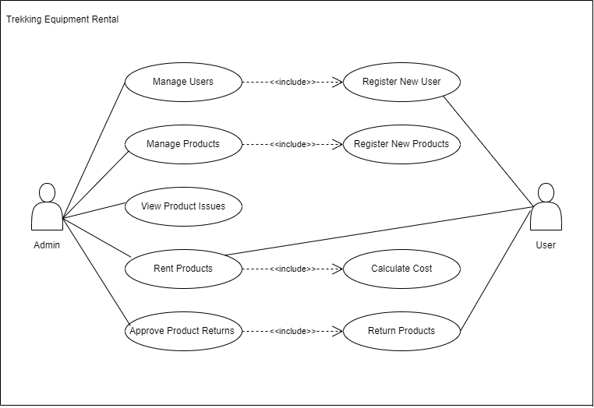

#### Fig 3.1.1.1: Use Case Diagram for Trekking Equipment Rental

1. **Non-Functional Requirements**

• Performance: The proposed website should identify users and equipment smoothly within feasible time.

• Security: The proposed website must be secure from unethical attacks like unauthorized access of the website.

• Reliability: The website must be reliable so that admin should able to confirm user name and password of authorized users.

• Maintainability: Website must be maintainable when failure occur.

• Availability: Website must be available whenever required.

### 3.1.2. Feasibility Analysis

1. **Technical:** For both end users and developers our project requires a simple hardware i.e. a computer or a laptop with normal processing speed and GUI based technology as well as good internet connection and software includes a visual studio code, Apache server, MySQL database which can be downloaded from many official respective sites. This project is completed in the most recent and widely used web development tool i.e. React as Front end and Laravel which is a powerful PHP framework with an average footprint(1.7GB), built for developers who need a simple and elegant toolkit to create full-featured web application. All the requirements can be easily available so we must say it is technically feasible.

**Web development tool:** React and Laravel.

**Tools used**: Visual Studio Code, XAMPP, Apache server, MySQL database

**Hardware Requirement:** A working computer system.

1. **Operational:** For the system to work functionally, basic computer knowledge, web site knowledge and power supply is necessary which is abundant in every organization and also as we mentioned earlier only few technologies will be used to operate the website and simple training demonstration of working website will be required for admin so it is operationally feasible.
2. **Economic:** As our project needs computers and some open-source software which can be easily available through internet surfing and are free of cost, the implementing cost will be very low compared to other websites with different hardware requirement systems and which uses premium software for development. Admin can operate our system with less effort and only few technologies are required so the cost of manpower is not a necessity that’s why it is economically feasible.
3. **Schedule:** Project Schedule is described below as a Gantt chart.

Table 3.1.2.1: Gantt Chart

|  |  |  |  |  |  |  |  |  |  |  |  |  |
| --- | --- | --- | --- | --- | --- | --- | --- | --- | --- | --- | --- | --- |
| Weeks  Phase | 1 | 2 | 3 | 4 | 5 | 6 | 7 | 8 | 9 | 10 | 11 | 12 |
| Study and analysis | 1W |  |  |  |  |  |  |  |  |  |  |  |
| Feasibility study |  | 2W |  |  |  |  |  |  |  |  |  |  |
| Data fetching & Coding |  |  |  |  | 4W |  |  |  |  |  |  |  |
| Implementation & testing |  |  |  |  |  | 3W |  |  |  |  |  |  |
| Documentation |  |  |  |  | 9W |  |  |  |  |  |  |  |
| Review |  |  | 1W |  |  |  |  |  |  |  | 1W |  |
| Presentation |  |  | 1W |  |  |  |  |  |  |  |  | 1W |

### 3.1.3. Analysis

* **Data Modelling (ER-Diagram)**



#### Fig 3.1.3.1: Data Modeling (ER-Diagram)

* **Process Modelling (DFD)**

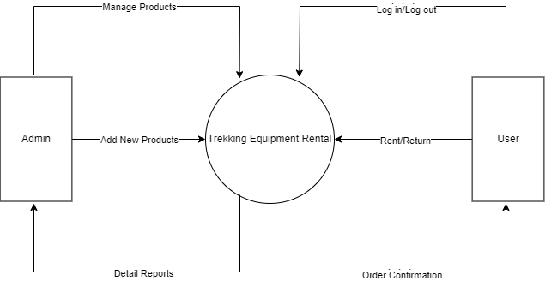

#### Fig 3.1.3.2: Process Modeling Level-0 DFD



#### Fig 3.1.3.3: Process Modeling Level-1 DFD



#### Fig 3.1.3.4: Process Modeling Level-2 DFD

# Chapter 4: System Design

## 4.1 Design

* **Architectural Design**

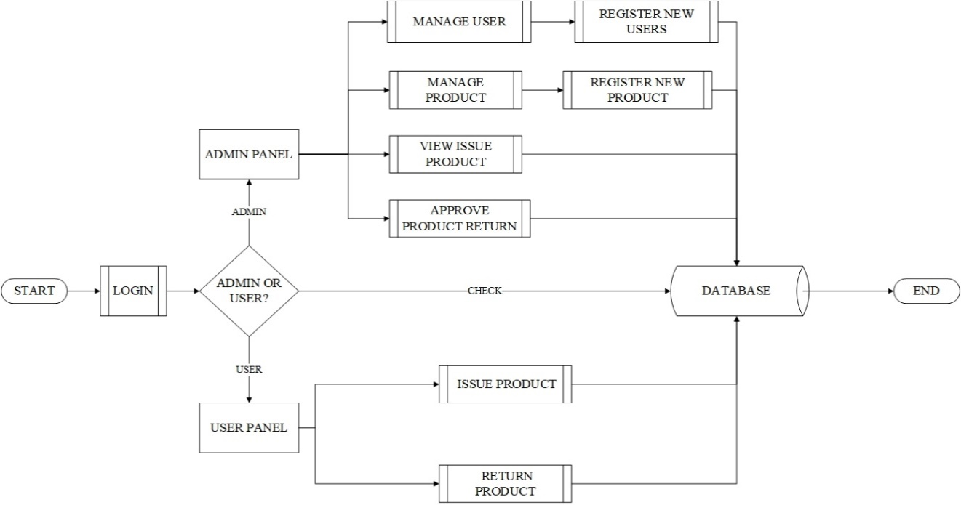

#### Fig 4.1.1: Architectural Design.

* **Database Schema Design**

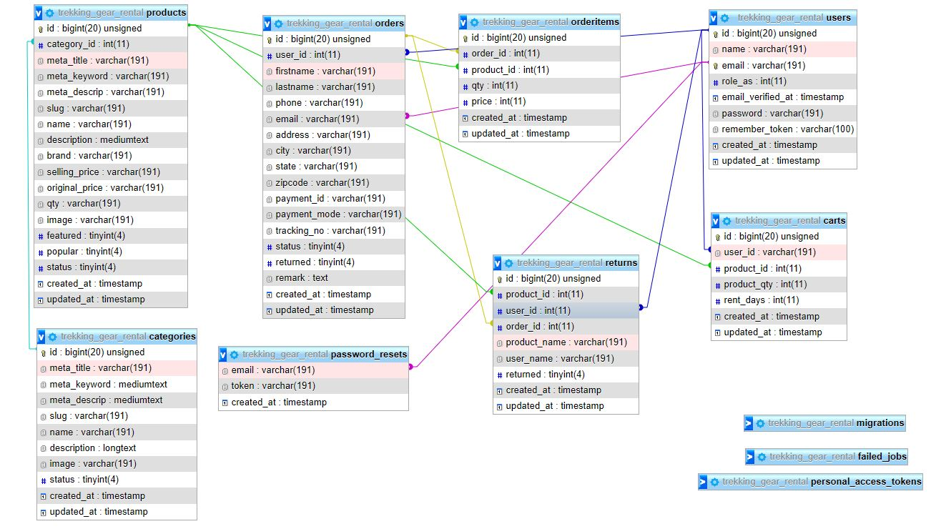

#### Fig 4.1.2: Database Schema Design

## 4.2 Algorithm Details

* **Sorting Algorithm (Used in both ViewCategory and ViewProduct):**

Both components utilize JavaScript's built-in .sort() method to sort data arrays alphabetically based on a specific property. In ViewCategory, the category array is sorted alphabetically based on the name property using the. sort() method with a comparison function (a, b) => a.name.localeCompare(b.name). In ViewProduct, the product array is sorted alphabetically based on the name property using the. sort() method with the same comparison function (a, b) => a.name.localeCompare(b.name). This comparison function compares the name property of two items and sorts them in alphabetical order in a case-insensitive manner using localeCompare.

Example: -

const sorted = [...category].sort((a, b) => a.name.localeCompare(b.name)); setSortedCategory(sorted);

* **Search Algorithm (Used in both ViewCategory and ViewProduct):**

Both components implement a basic substring search algorithm using the .filter() method to filter data based on a search query. In ViewCategory, the sortedCategory array is filtered based on whether the name of each category includes the lowercase search query. The name and search query are converted to lowercase for a case-insensitive search. In ViewProduct, the sortedProducts array is filtered based on whether the name of each product includes the lowercase search query. Again, both the name and search query are converted to lowercase for a case-insensitive search. These algorithms enable users to sort data alphabetically and search for specific items by name in a case-insensitive manner, enhancing the user experience when browsing categories and products.

Example: -

const filteredCategories = sortedCategory.filter((item) => item.name.toLowerCase().includes(searchQuery) );

* **Hashing Algorithm (Used to encrypt password)**:

Hashing algorithms, such as MD5, SHA-1, or SHA-256, are used for data security and integrity, particularly when dealing with sensitive information like passwords. We had usedaHashfunction, which also known asBcrypt is a widely used and secure password hashing algorithm that incorporates a salt (a random value) and multiple rounds of hashing to protect against brute-force attacks and rainbow table attacks.

Example: -

'bcrypt' => [ 'rounds' => env('BCRYPT_ROUNDS', 10), ], 'password'=>Hash::make($request->password),

# Chapter 5: Implementation and Testing

## 5.1. Implementation

### 5.1.1. Tools Used

**a) React:**

React is a JavaScript library known for simplifying the creation of interactive user interfaces through its component-based architecture and efficient rendering using a virtual DOM, often integrated with backend frameworks like Laravel to build full-stack applications.

**b) HTML:**

HTML (Hypertext Markup Language) is the standard language used to create and design web pages, defining their structure and content through a series of markup tags.

**c) CSS:**

CSS (Cascading Style Sheets) is a stylesheet language used to define the presentation and styling of HTML documents, enabling web designers to control layout, colors, fonts, and other visual aspects of web pages.

**d) Laravel:**

Laravel is a free, open-source PHP web framework, known for its elegant syntax, robust features, and developer-friendly tools, facilitating the development of modern web applications with ease and efficiency, utilizing the MVC (Model-View-Controller) architectural pattern, and integrating with frontend technologies like React for building interactive user interfaces.

**e) PHP:**

PHP (Hypertext Preprocessor) is a server-side scripting language, commonly employed in web development, often in frameworks like Laravel, to build dynamic web pages and interactive applications, frequently integrating with databases such as MySQL and employing tools like PhpMyAdmin for database administration.

**f) SQL:**

SQL (Structured Query Language) is a domain-specific language used for managing and manipulating relational databases, often implemented alongside tools like XAMPP, which provides an environment for running Apache, MySQL, PHP, and other components essential for web development and database management.

**g) XAMPP:**

XAMPP is a free and open-source cross-platform web server solution stack package developed by Apache Friends, containing Apache HTTP Server, MySQL database, and interpreters for scripts written in the PHP and Perl programming languages.

**h) Visual Studio Code:**

Visual Studio Code, commonly known as VS Code, is a popular source-code editor developed by Microsoft, renowned for its lightweight design, extensive features, and broad ecosystem of extensions, making it a versatile tool for various programming languages and development tasks, with built-in support for version control systems like Git.

### 5.1.2. Implementation Details of Modules (Description of procedures/functions)

**a) Client (Admin Side):**

Table 4.1.2.1: Clients Software Requirements

|  |  |
| --- | --- |
| Browsers | Mozilla, Chrome |

**b) Developer Side:**

Table 4.1.2.2: Software Developer Requirements

|  |  |
| --- | --- |
| Operating System | Windows 7,8,10,11 |
| IDE | Visual Studio Code |
| Database server | MySQL |
| Programming language | PHP, JavaScript, HTML, CSS |

**c) Client Side:**

Table 4.1.2.3: Clients Software Requirements

|  |  |
| --- | --- |
| Browsers | Mozilla, Chrome |

**d) Server Side:**

Table 4.1.2.4: Server Side

|  |  |
| --- | --- |
| Operating System | Windows |
| Web Server | Apache Server |
| Database | MySQL Server |

## 5.2. Testing

### 5.2.1. Test Cases for Unit Testing

Table 4.2.1.1: Test Cases for Unit Testing

|  |  |  |  |  |  |
| --- | --- | --- | --- | --- | --- |
| **Test case** | **Preconditions** | **Steps to be Executed** | **Expected Results** | **Actual Results** | **Pass/Fail** |
| Login for User | The user account should be registered | Trying to login leaving blank textbox | login error indicating missing information | Showed message: email and password field are required | Pass |
| Login for User | The user account should be registered | Enter username and password Click Login | User must successfully login to the profile | User is successfully logged in | Pass |
| Login for Admin | The admin account should be registered | Enter username and wrong password Click Login | Admin must successfully login to the profile | Admin is successfully logged in | Pass |
| Register User | For creating user account | Enter name, email address, and password  Click Register | Account must be created. | Account is created. | Pass |

### 5.2.2. Test Cases for System Testing

System Testing (ST) is a black box testing technique performed to evaluate the complete system's compliance against specified requirements. In System testing, the functionalities of the system are tested from an end-to-end perspective. System testing is the testing to ensure that by putting the software in different environments (e.g. Browsers) it still works.

Table 5.2.2.1: Test Cases for System Testing

|  |  |  |  |  |  |
| --- | --- | --- | --- | --- | --- |
| **Test case** | **Preconditions** | **Steps to be Executed** | **Expected Results** | **Actual Results** | **Pass/Fail** |
| Searching for Category | The user should Login first | Navigate to Category page and search for category | User must get searched Category | User successfully getting searched category | Pass |
| Searching for Product | The user should Login first | Navigate to Product page and search for product | User must get searched Product | User successfully getting searched product | Pass |
| View full details of Product | The user should Login first | Navigate to Product page and click on the product | User must get details of the clicked Product | User successfully getting details of clicked product | Pass |
| Adding to cart | The user should Login first | Navigate to Product detail page and click on the add to cart button | Product added to cart | Product successfully added to cart. | Pass |
| Ordering Product | User must login | Navigate to Cart page and click on checkout button and fill all the required details  and press place order to order | Product ordered | Ordered successfully | Pass |
| Initiating  Return of  Product | User must login | Navigate to My Orders page and click on the Return button | Initiating Product return | Return Initiated  successfully | Pass |
| Approving return | Admin must login | Navigate to Returns page and click on the Approve button | Return must be approved | Approved  successfully | Pass |
| Adding Category | Admin must login | Navigate to Add Category page and fill all the information and click on the Submit button | Category must be added | Category added successfully. | Pass |
| Adding Product | Admin must login | Navigate to Add Product page and fill all the information and click on the Submit button | Product must be added | Product added successfully | Pass |

# Chapter 6: Conclusion and Future Recommendations

## 6.1. Conclusion

By the research we have done in the field of website development and designing while developing this project we have definitely gained some knowledge and hope in upcoming future we will be doing many more projects in the field of website development.

During the development of this project, we have learned many practical knowledge such as documentation, presentation, time management, resource management overall we have gain knowledge of website development. We have also gain experience of working as a team while developing this website, which we hope will be very useful while operating in corporate organization as well.

We can expect a fully functional website that can meet all the necessary needs of the consumer. Such as providing quality services as well as budget friendly products according to the needs and desire of the consumer with fast and easy service. Making the trekking and renting more convenient and budget-friendly as possible.

## 6.2. Future Recommendations

In upcoming future, we will definitely refine our project with following enhancement.

1. Adding package system from client side so that users will be able to order fully customized packages.
2. Making the project more automatic and reliable as possible.
3. Developing user friendly mobile application version of this website.

# References

|  |  |
| --- | --- |
| [1] | "Buying and Renting Trekking Gear in Kathmandu," Switch Back Travel, [Online]. Available: https://www.switchbacktravel.com/nepal/buying-renting-trekking-gear-kathmandu. [Accessed 3 12 2023]. |
| [2] | "Buying and Renting Trekking Gears in Kathmandu," Himalayan Glacier, [Online]. Available: https://www.himalayanglacier.com/renting-or-buying-hiking-gears-in-kathmandu/. [Accessed 3 12 2023]. |
| [3] | "Renting or Buying Hiking Gears in Kathmandu," Manaslu Guide, [Online]. Available: https://manasluguide.com/trekking-shopping-kathmandu/. [Accessed 3 12 2023]. |
| [4] | "TIPS FOR BUYING AND RENTING TREKKING GEARS IN KATHMANDU," Swotah Travel, [Online]. Available: https://www.swotahtravel.com/blogs/buying-and-renting-trekking-gears-in-kathmandu. [Accessed 3 12 2023]. |
| [5] | "Trekking Shopping on a Budget: Find the Best Deals in Kathmandu," Nepal Trek Routes, [Online]. Available: https://nepaltrekroutes.com/buying-and-renting-trekking-gears-in-kathmandu/. [Accessed 3 12 2023]. |

# Appendices

**Home:**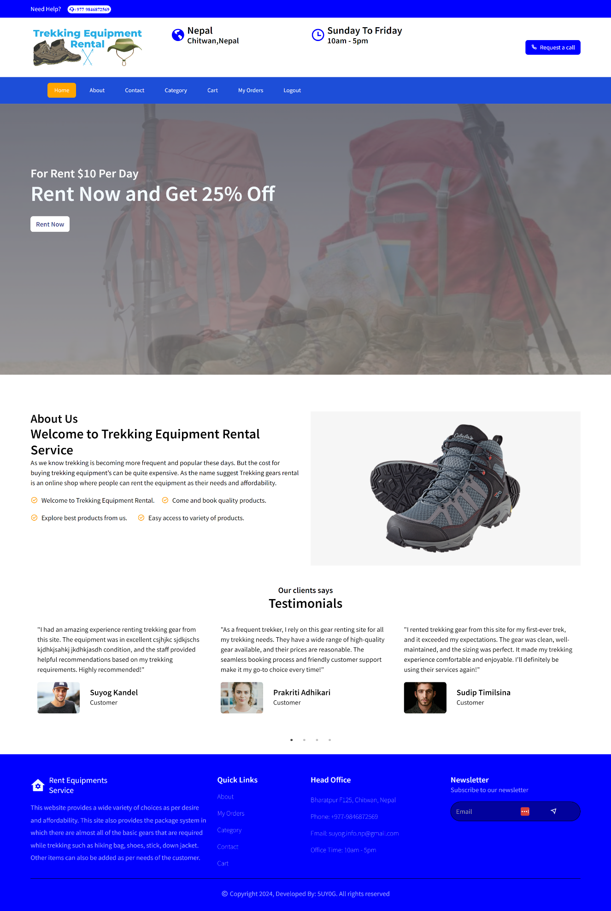

**About:** 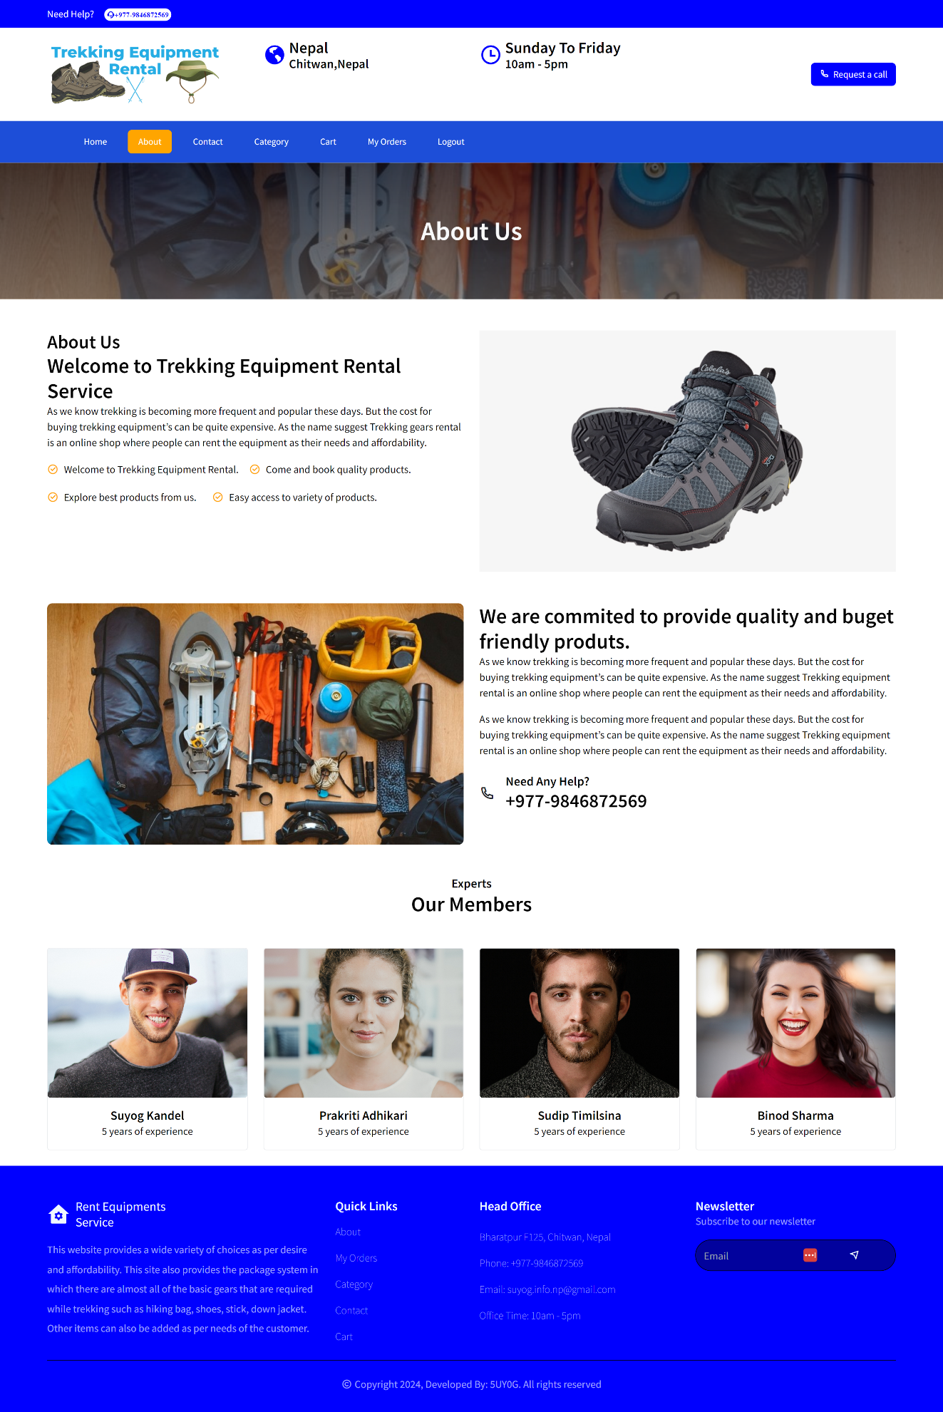

**Contact:** 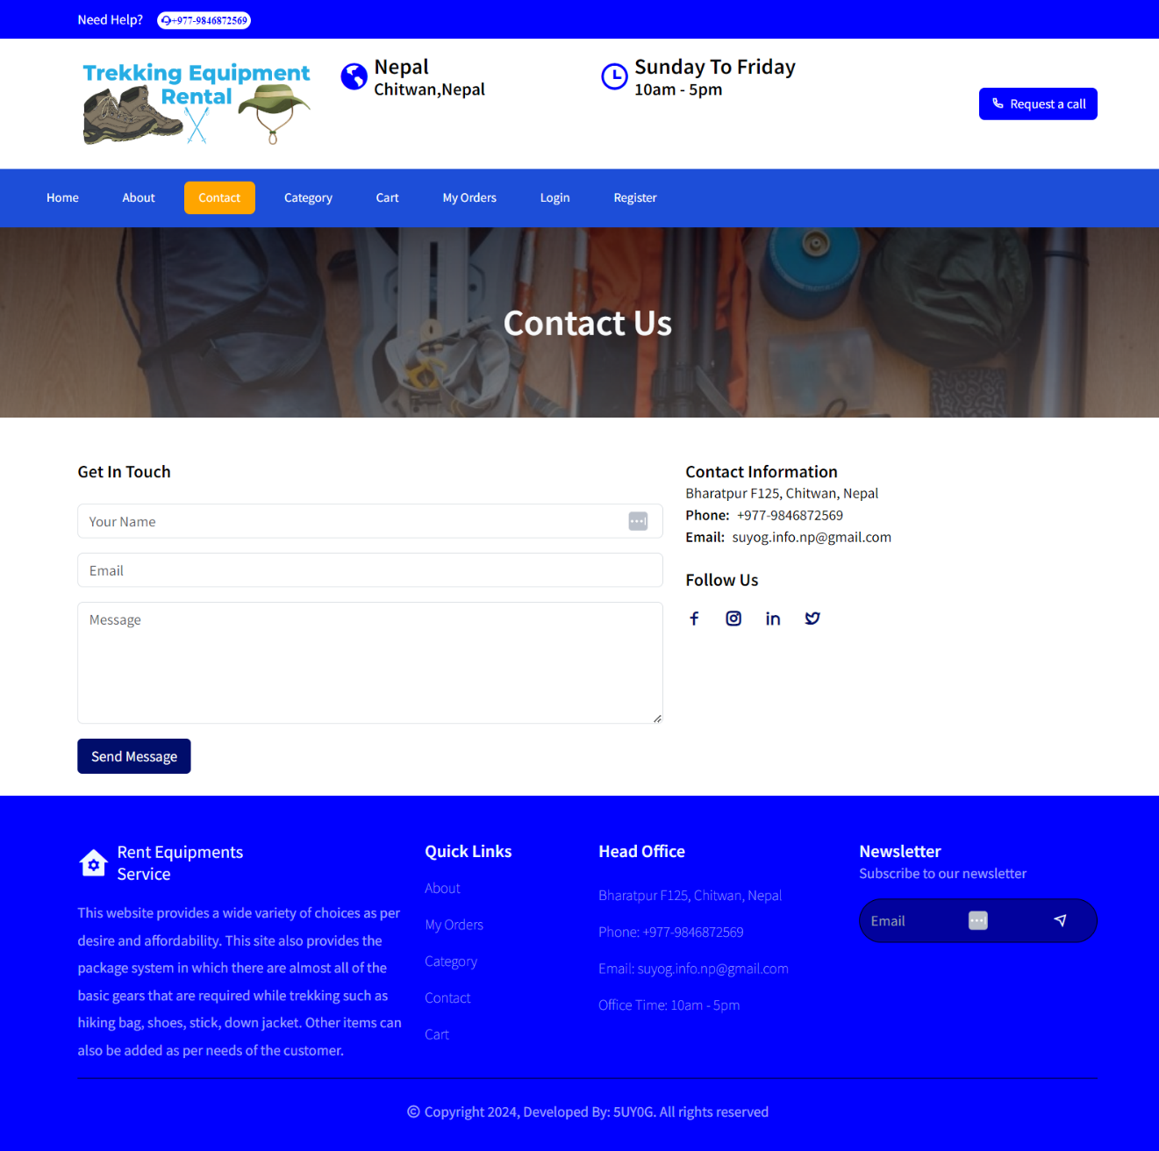

**Register: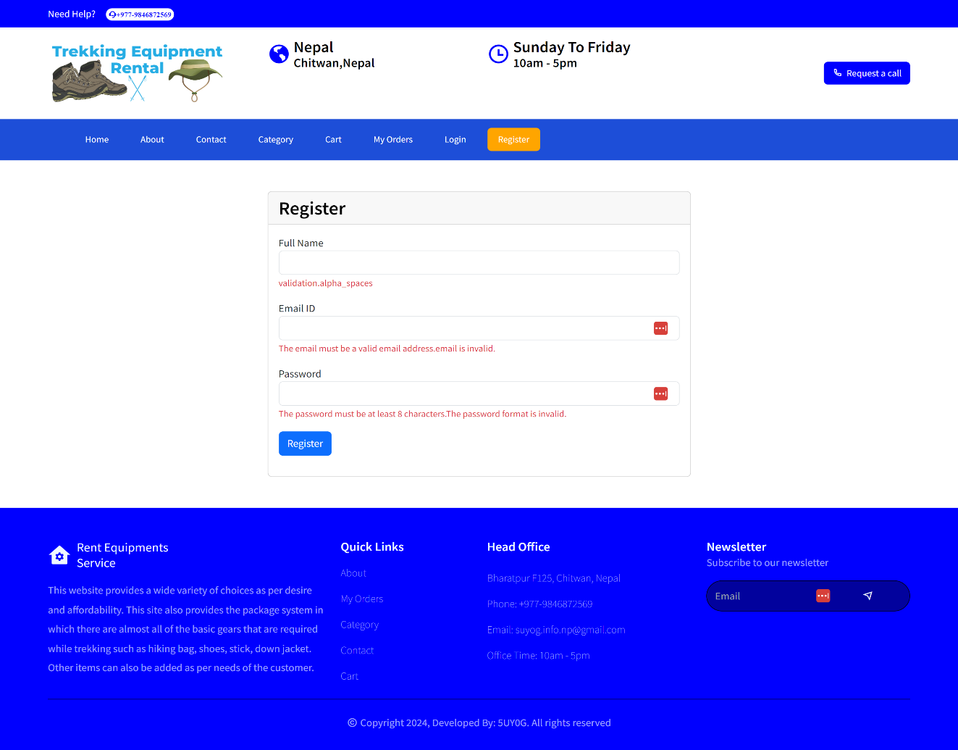Login: 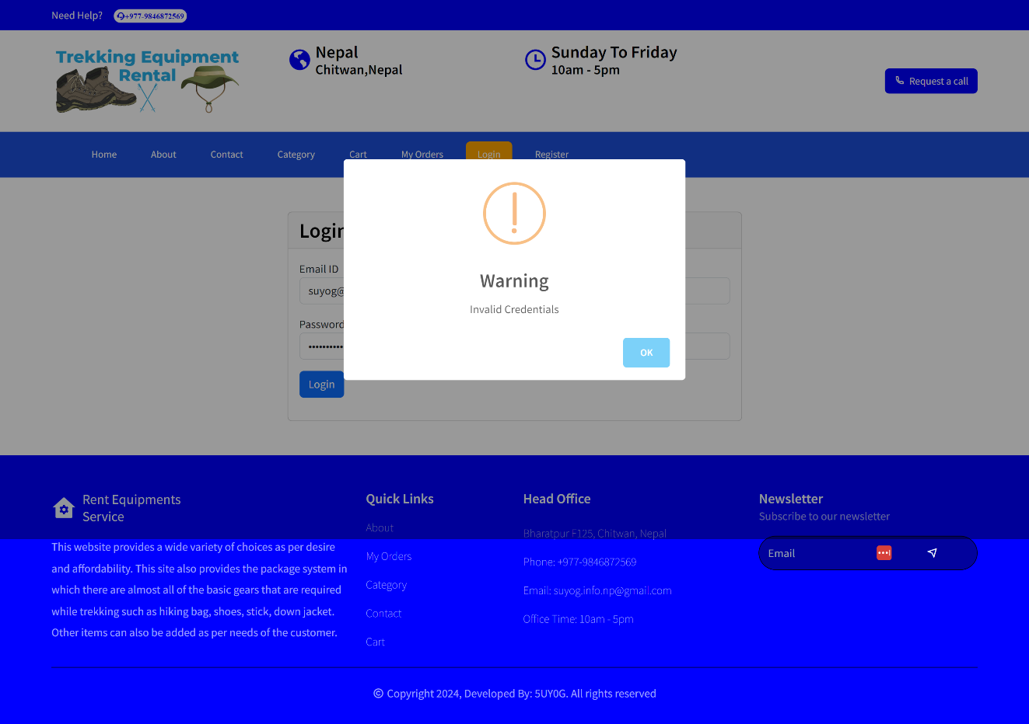Categories:**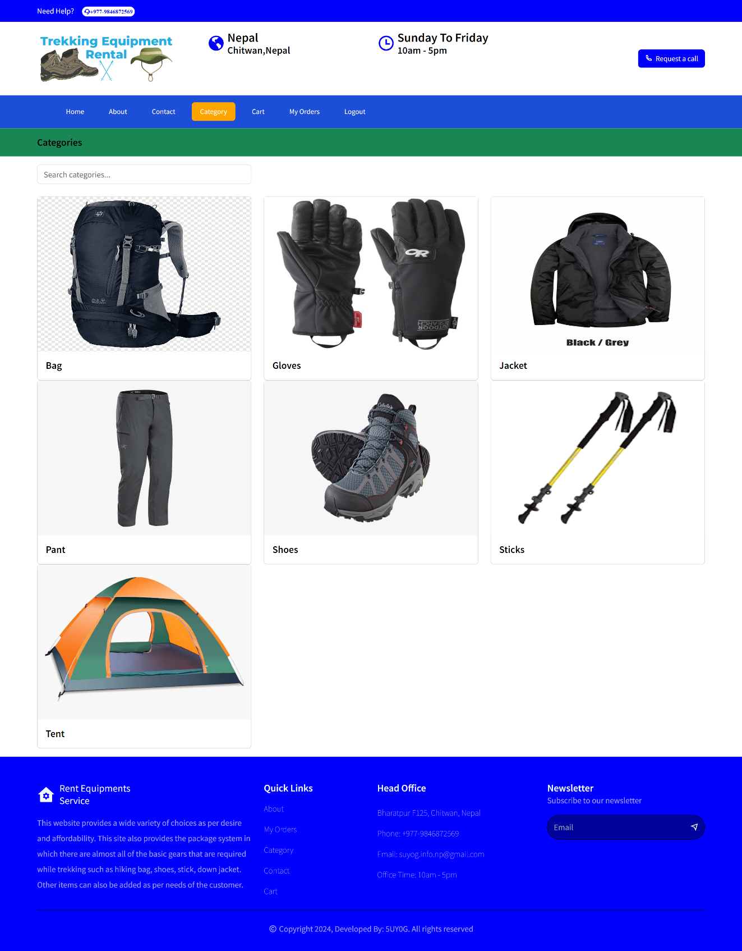

**Cart:**

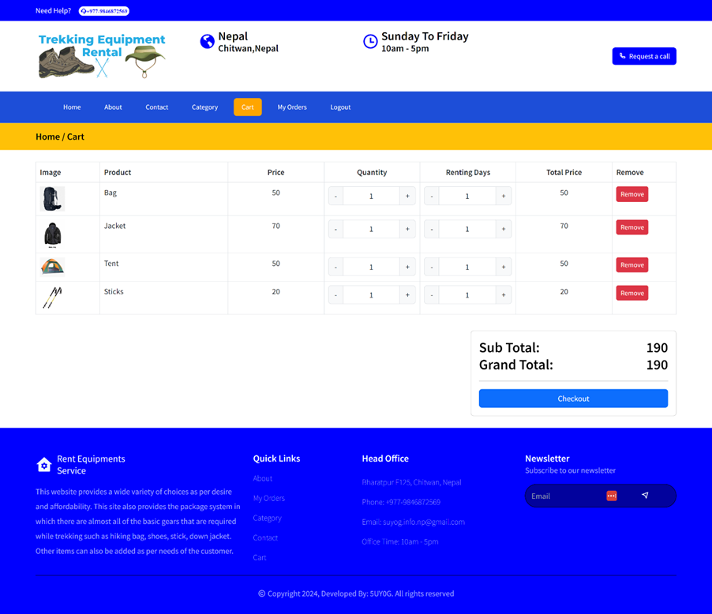

**Checkout:**

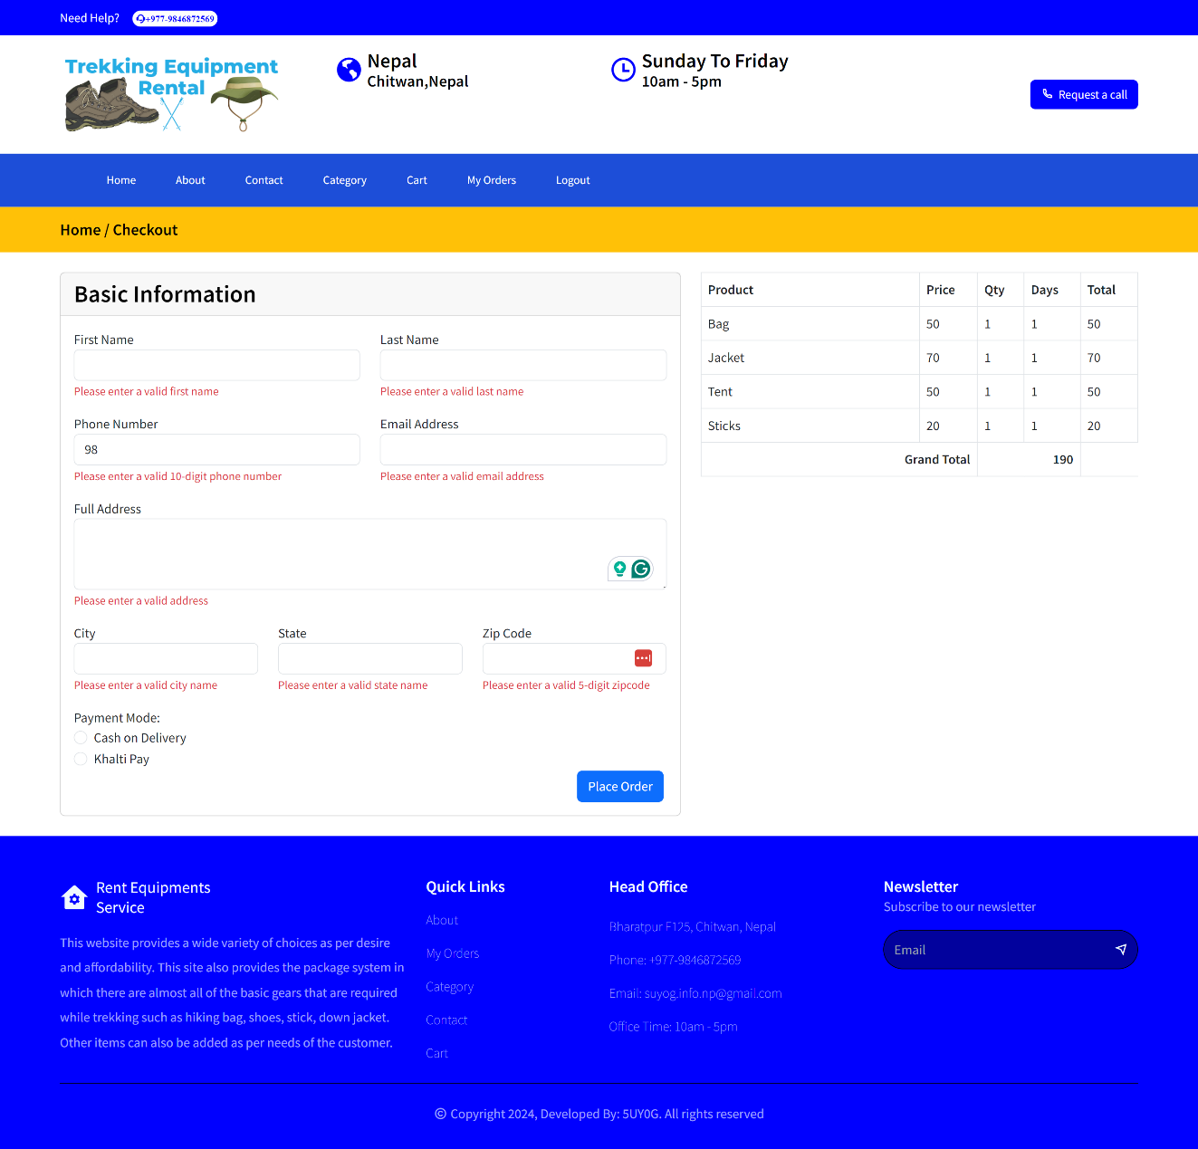

**Khalti Wallet:**

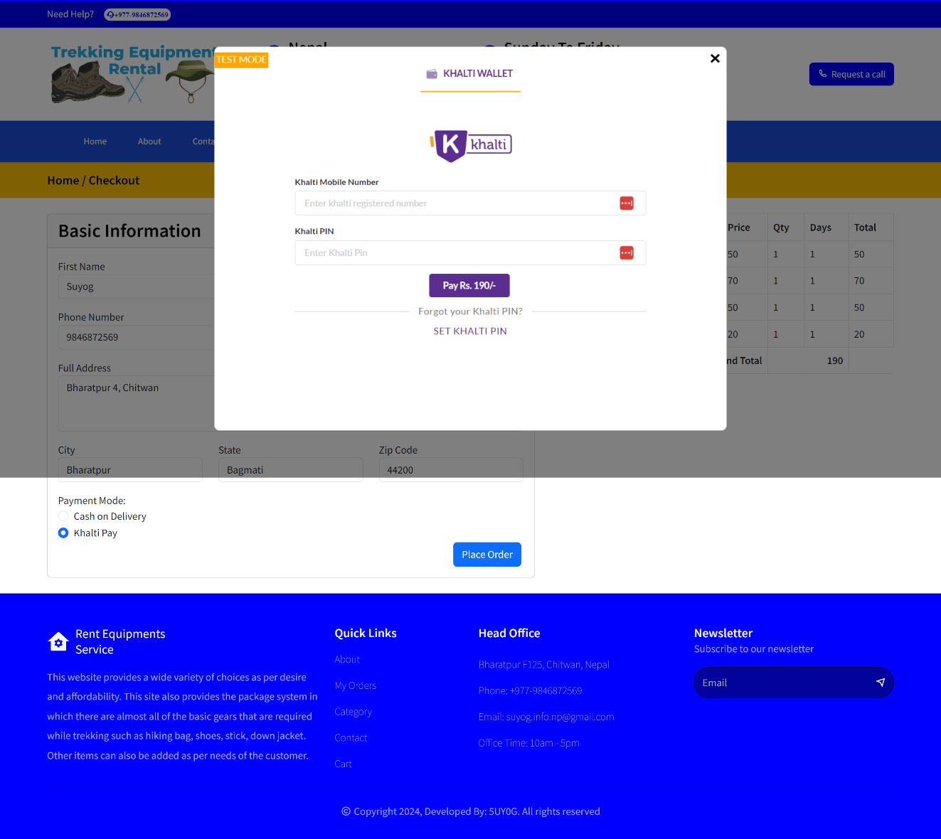

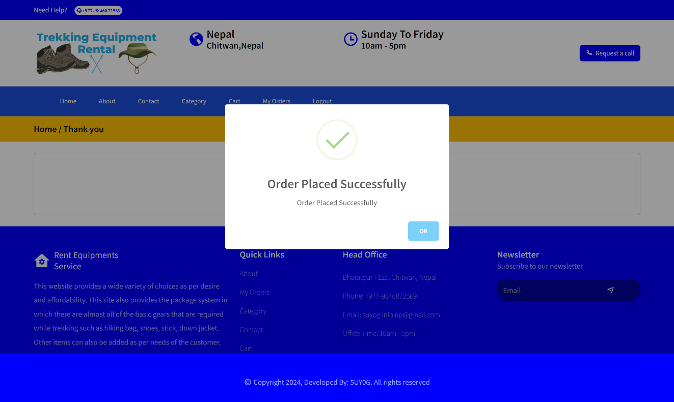

**My Orders:**

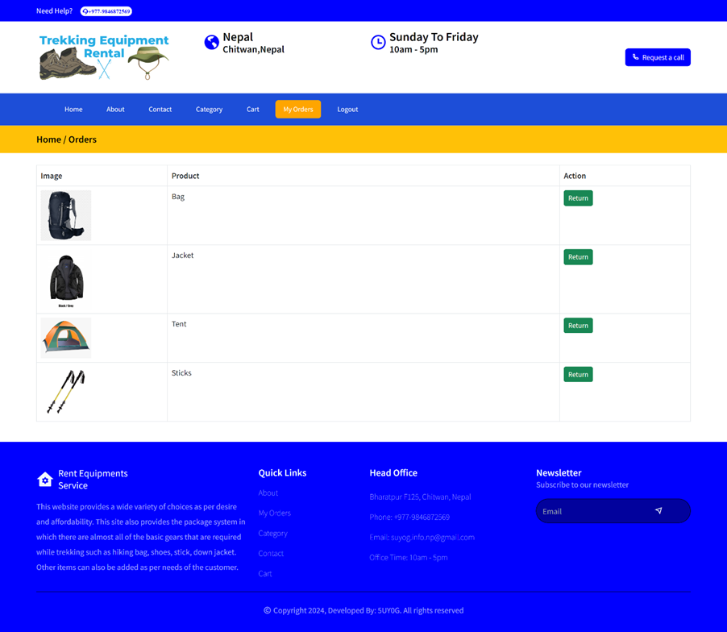

**Admin/Dashboard:**

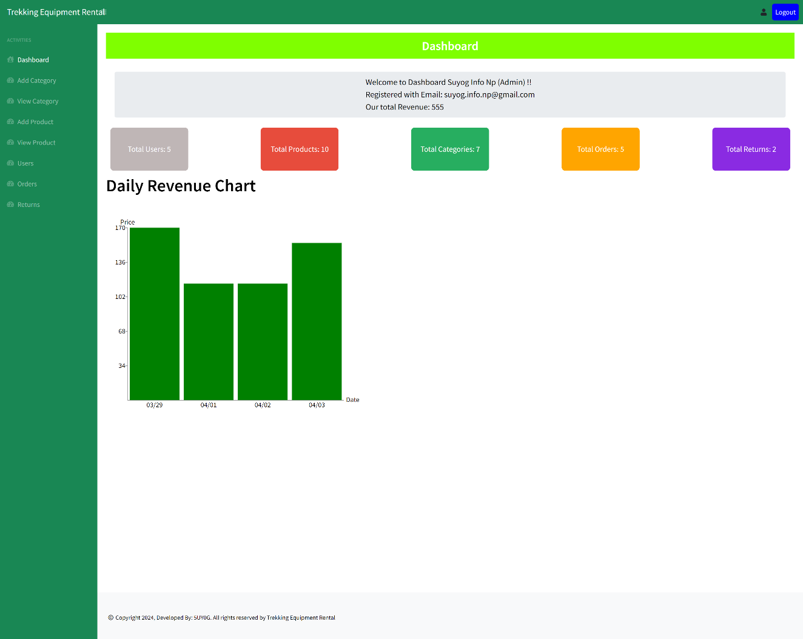

**View Category:**

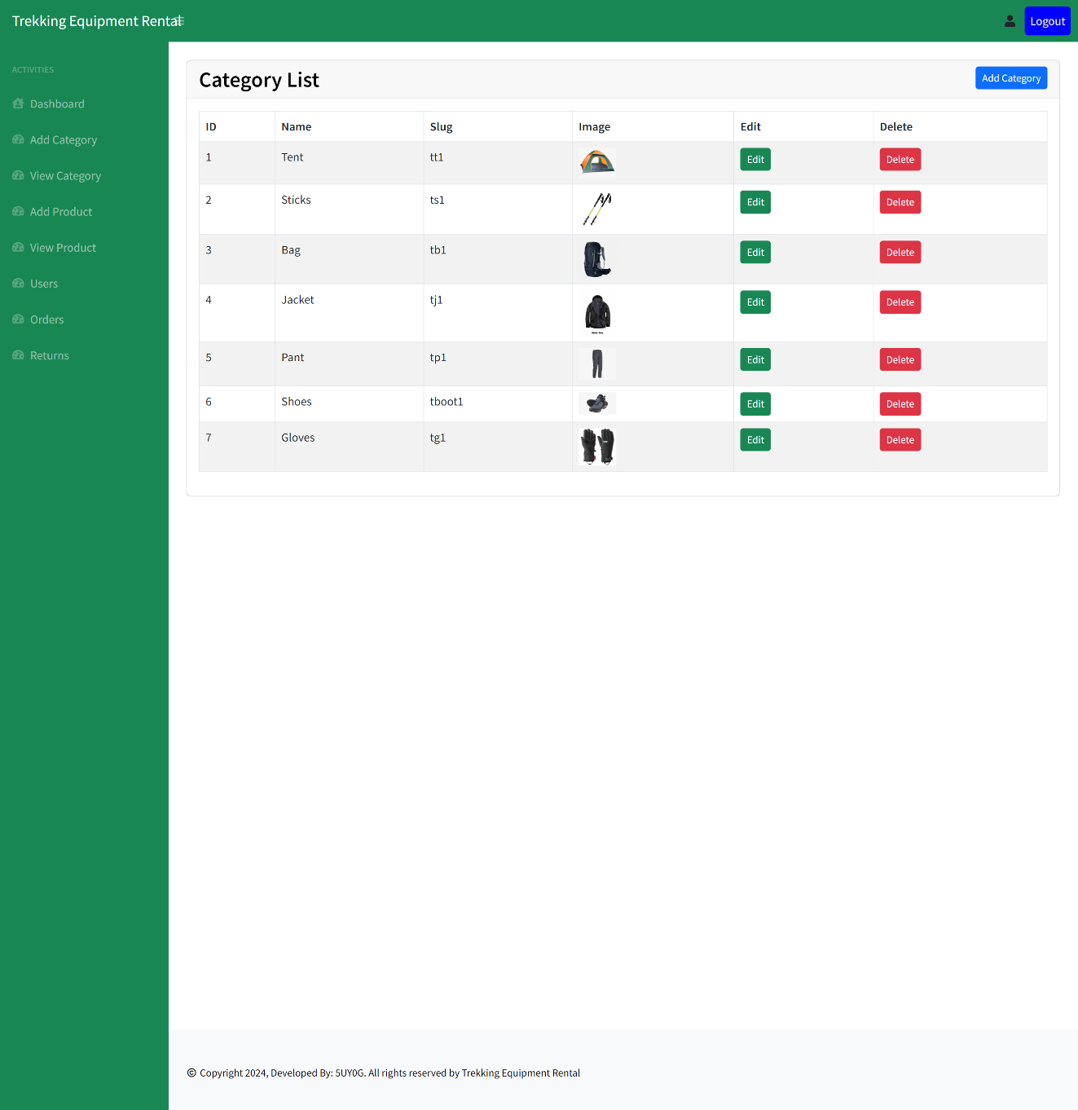

**View Product:**

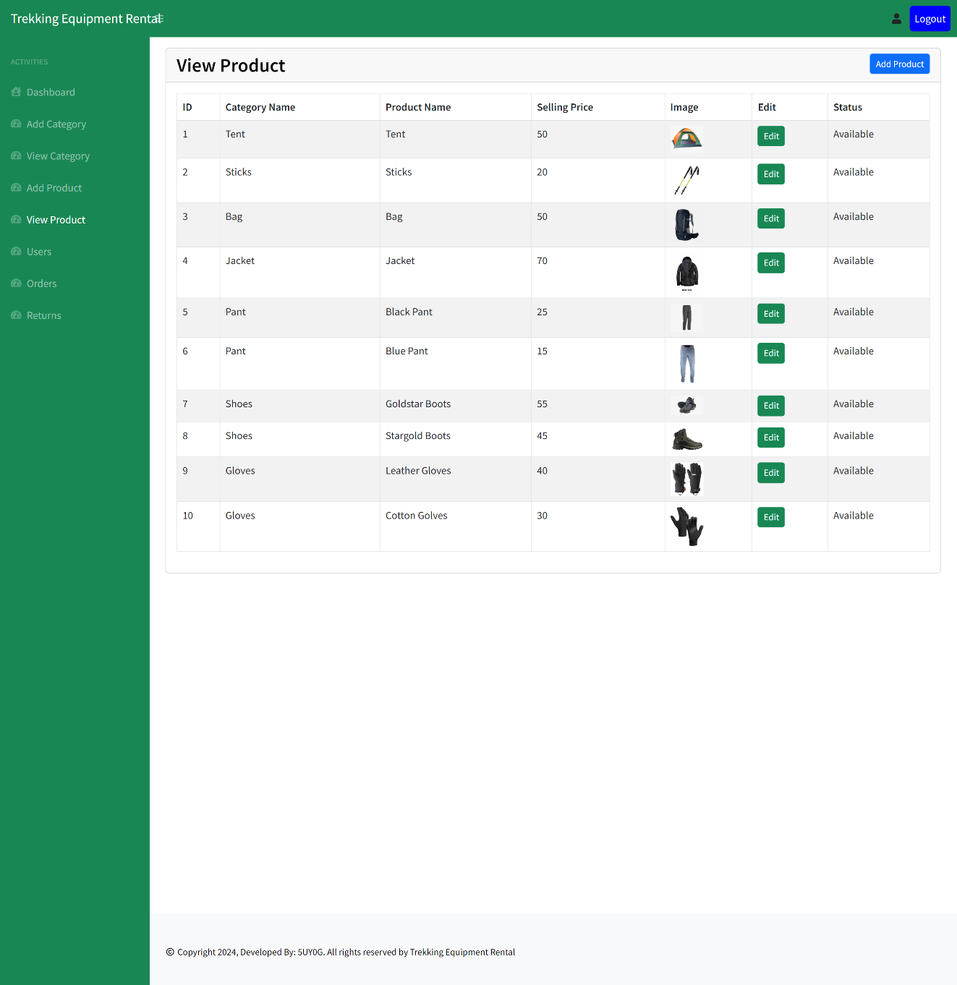

**Users:**

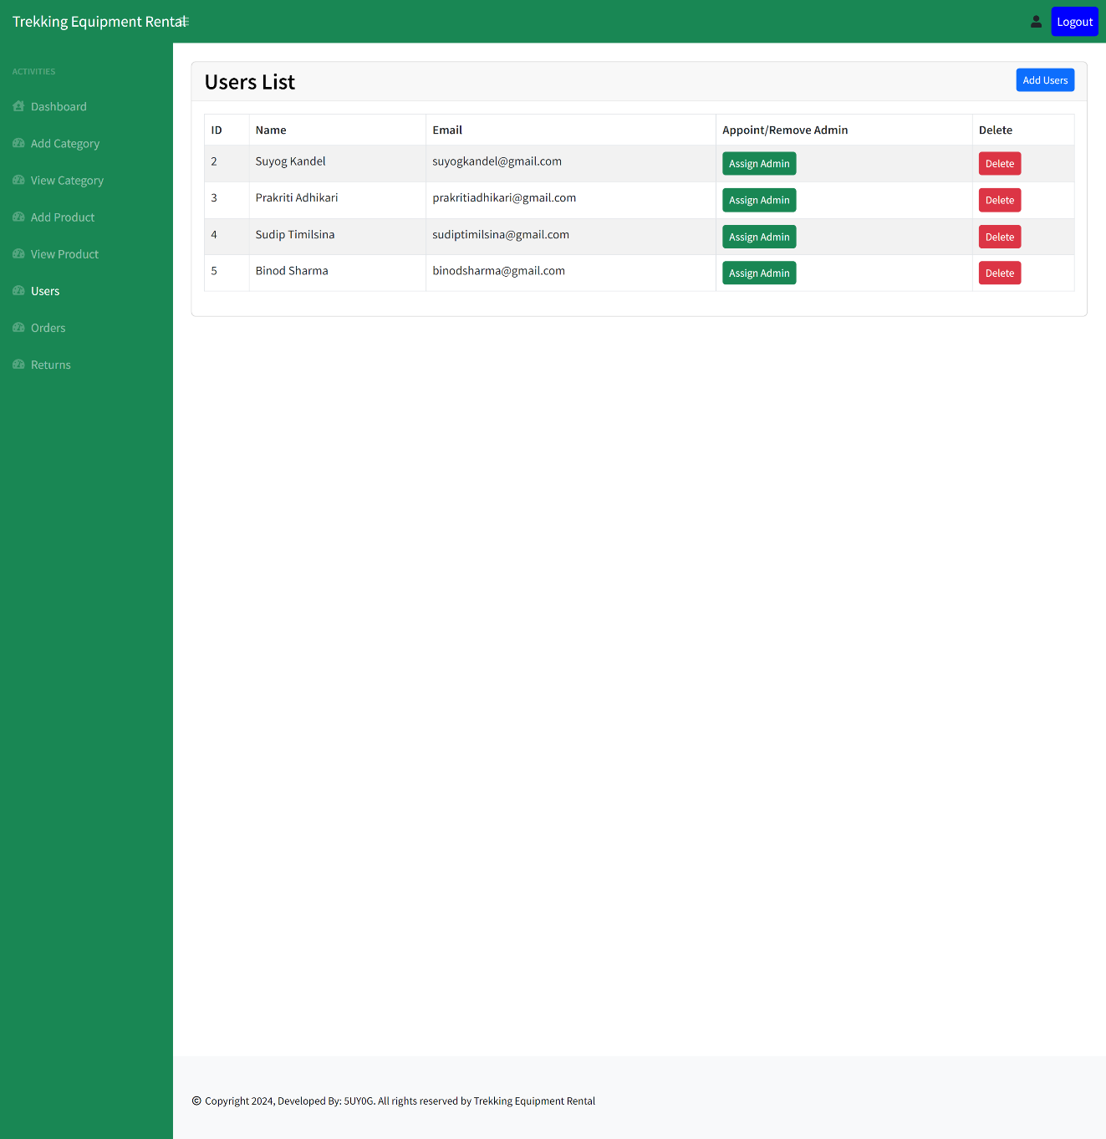

**Orders:**

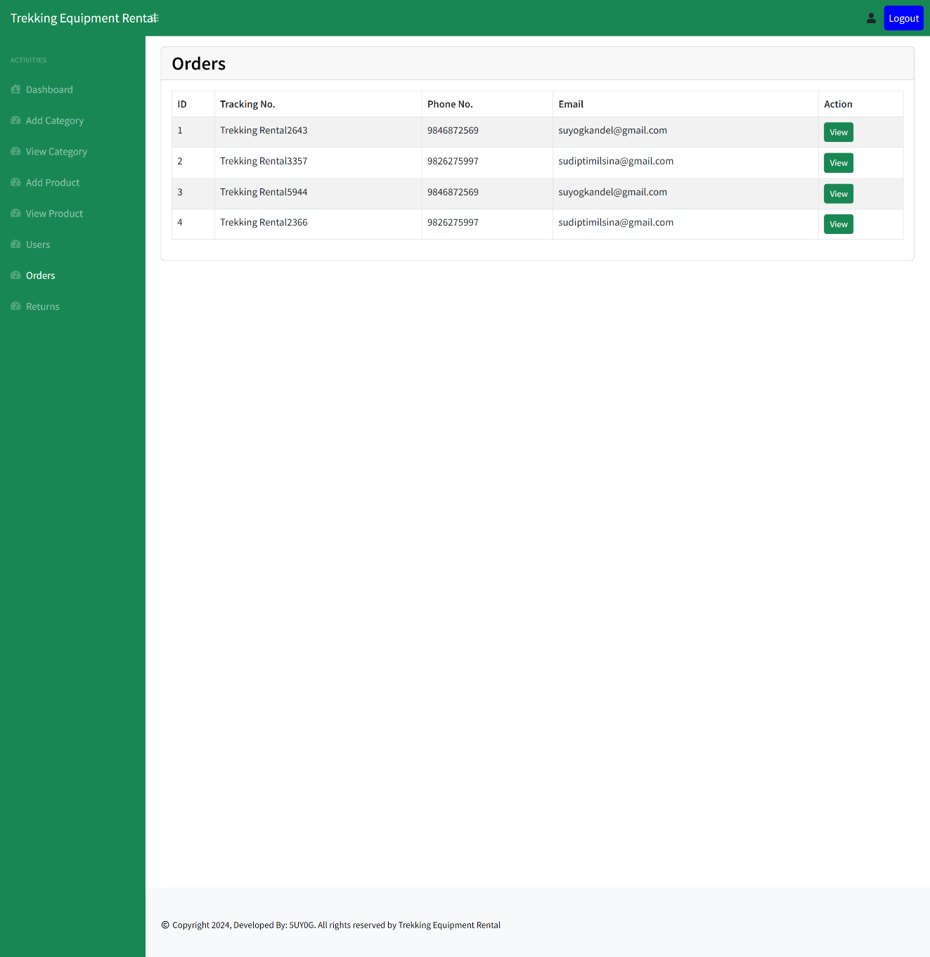

**Returns:**

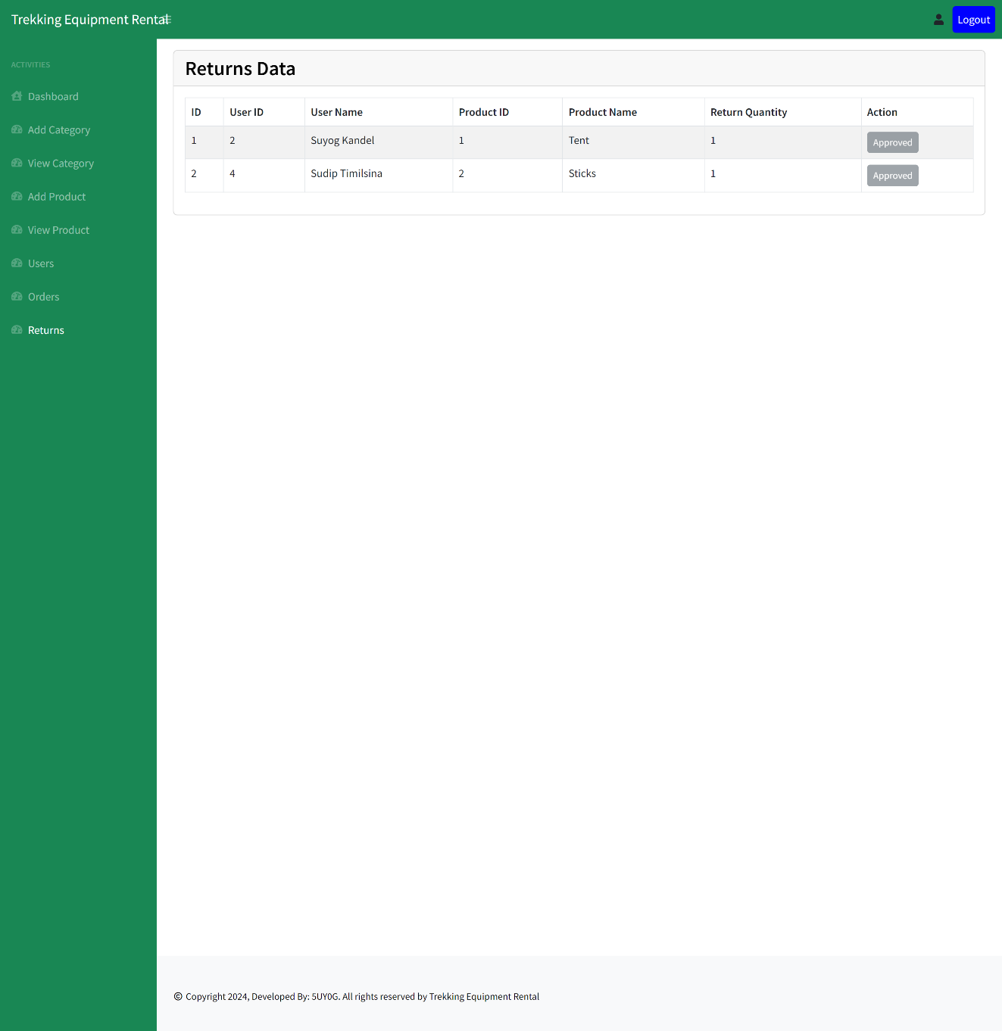

**Database Server (MySQL):**

